**Application Project**

**(Dates)**

**BEFORE**

**AFTER**

The dates (and times) need to alternate for every new post by 0 to 5 days randomly.

Currently all the dates of the posts and times are the same. This is not good because it is impossible

for every person to post exactly at the same date and time!

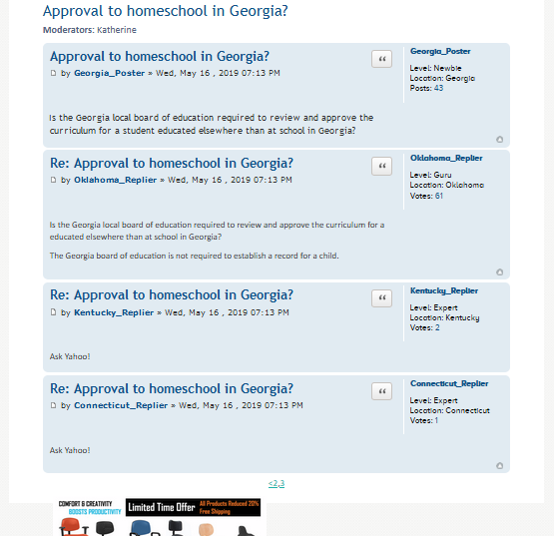 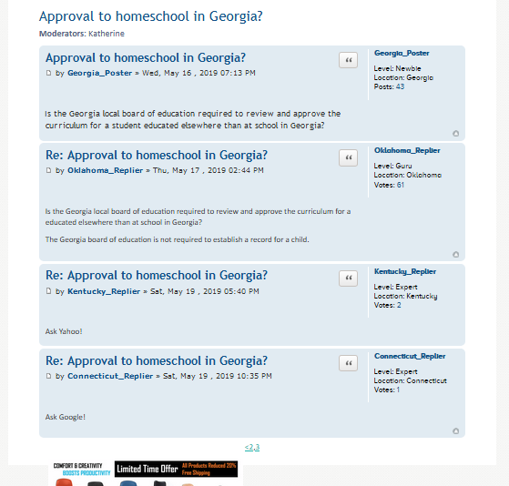



Notice the day can be the same because it is random (0,5), but the time must always be different.

**Application Project**

**(Dates)**

**Interface Change**

**AFTER**

Date select, time will be chosen randomly (PM time). If it’s easier to program, I can select start time too.

**BEFORE (NOW)**

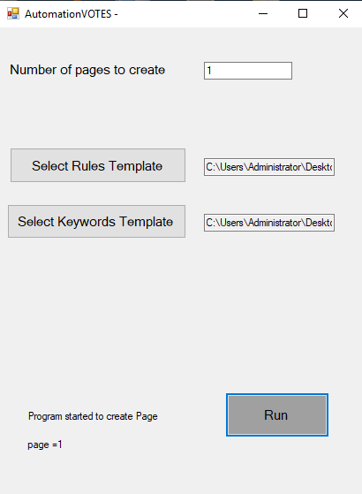 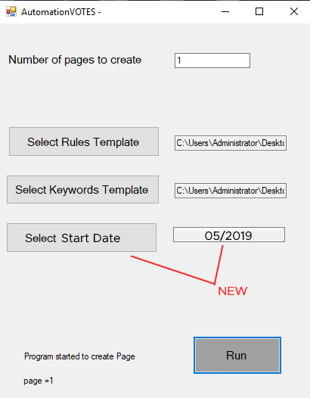

**Application Project**

**(Mark Up Code Generate) - NEW**

**Output HTML will include mark up insertions in the beginning of the HTML code the program generates**

The code below is basically always the same. We just need to “insert” parts of the information created by our program. The information in green below is the information the program generates. The rest is static code.

<html>  
  <head>  
    <title> Approval to homeschool in Georgia?</title>  
    <script type="application/ld+json">  
    {  
      "@context": "https://schema.org",  
      "@type": "QAPage",  
      "mainEntity": {  
        "@type": "Question",  
        "name": "Is the Georgia local board of education required to review and approve the curriculum for a student educated elsewhere than at school in Georgia?",  
        "text": " Is the Georgia local board of education required to review and approve the curriculum for a student educated elsewhere than at school in Georgia?",  
        "answerCount": 3,  
        "upvoteCount": 26,  
        "dateCreated": "2019-05-16T19:13Z",  
        "author": {  
          "@type": "Person",  
          "name": "Georgia_Poster"  
        },  
        "acceptedAnswer": {  
          "@type": "Answer",  
          "text": "Is the Georgia local board of education required to review and approve the curriculum for a educated elsewhere than at school in Georgia?

The Georgia board of education is not required to establish a record for a child.",  
          "dateCreated": "2019-05-17T14:44Z",  
          "upvoteCount": 61,  
          "url": "https://example.com/question1#acceptedAnswer",  
          "author": {  
            "@type": "Person",  
            "name": "Oklahoma_Replier"  
          }  
        },  
        "suggestedAnswer": [  
          {  
            "@type": "Answer",  
            "text": "Ask Yahoo!",  
            "dateCreated": "2019-05-19T17:40Z",  
            "upvoteCount": 2,  
            "url": "https://example.com/question1#suggestedAnswer1",  
            "author": {  
              "@type": "Person",  
              "name": "Kentucky_Replier"  
            }  
          }, {  
            "@type": "Answer",  
            "text": " Ask Google!",  
            "dateCreated": "2019-05-02T17:40Z ",  
            "upvoteCount": 1,  
            "url": "https://example.com/question1#suggestedAnswer2",  
            "author": {  
              "@type": "Person",  
              "name": "Connecticut_Replier"  
            }  
          }  
        ]  
      }  
    }  
    </script>  
  </head>  
  <body>  
  </body>  
</html>

For each new answer static codes adds this

**Application Project**

**(Mark Up Code Generate) - NEW**

Explanation of where the code is taken from for each section. Basically we simply insert the meta title field, question, answer count, date, vote count, username. Alternatively, you can generate the entire code on the right if it’s too complicated to “insert it” (fill in the appropriate sections). The code on the right will be added to the very top of the code the program generates.

<html>  
  <head>  
    <title> Approval to homeschool in Georgia?</title>  
    <script type="application/ld+json">  
    {  
      "@context": "https://schema.org",  
      "@type": "QAPage",  
      "mainEntity": {  
        "@type": "Question",  
        "name": "Is the Georgia local board of education required to review and approve the curriculum for a student educated elsewhere than at school in Georgia?",  
        "text": " Is the Georgia local board of education required to review and approve the curriculum for a student educated elsewhere than at school in Georgia?",  
        "answerCount": 3,  
        "upvoteCount": 43,  
        "dateCreated": "2019-05-16T19:13Z",  
        "author": {  
          "@type": "Person",  
          "name": "Georgia_Poster"  
        },  
        "acceptedAnswer": {  
          "@type": "Answer",  
          "text": "Is the Georgia local board of education required to review and approve the curriculum for a educated elsewhere than at school in Georgia? The Georgia

board of education is not required to establish a record for a child.",  
          "dateCreated": "2019-05-17T14:44Z",  
          "upvoteCount": 61,  
          "url": "https://example.com/question1#acceptedAnswer",  
          "author": {  
            "@type": "Person",  
            "name": "Oklahoma_Replier"  
          }  
        },  
        "suggestedAnswer": [  
          {  
            "@type": "Answer",  
            "text": "Ask Yahoo!",  
            "dateCreated": "2019-05-19T17:40Z",  
            "upvoteCount": 2,  
            "url": "https://example.com/question1#suggestedAnswer1",  
            "author": {  
              "@type": "Person",  
              "name": "Kentucky_Replier"  
            }  
          }, {  
            "@type": "Answer",  
            "text": " Ask Google!",  
            "dateCreated": "2019-05-02T17:40Z ",  
            "upvoteCount": 1,  
            "url": "https://example.com/question1#suggestedAnswer2",  
            "author": {  
              "@type": "Person",  
              "name": "Connecticut_Replier"  
            }  
          }  
        ]  
      }  
    }  
    </script>  
  </head>  
  <body>  
  </body>  
</html>

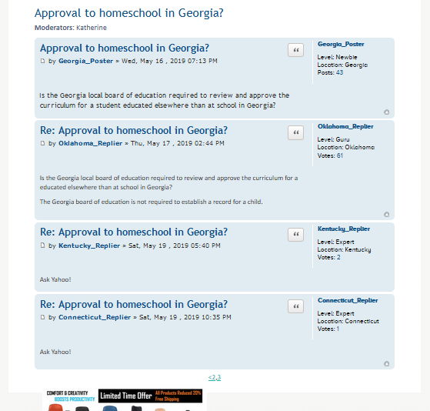



This will be the URL of this page that the program already creates

Total number of “answers” in keywords CSV template. If it’s too complicated for you to read template header. I can enter this value manually if you add an input box.

<script type="application/ld+json">// <![CDATA[

{

"@context": "https://schema.org",

"@type": "QAPage",

"mainEntity": {

"@type": "Question",

"name": "Is the Georgia local board of education required to review and approve the curriculum for a student educated elsewhere than at school in Georgia?",

"text": " Is the Georgia local board of education required to review and approve the curriculum for a student educated elsewhere than at school in Georgia?",

"answerCount": 3,

"upvoteCount": 26,

"dateCreated": "2019-05-16T19:13Z",

"author": {

"@type": "Person",

"name": "Georgia_Poster"

},

"acceptedAnswer": {

"@type": "Answer",

"text": "Is the Georgia local board of education required to review and approve the curriculum for a educated elsewhere than at school in Georgia?

The Georgia board of education is not required to establish a record for a child.",

"dateCreated": "2019-05-17T14:44Z",

"upvoteCount": 61,

"url": "https://example.com/question1#acceptedAnswer",

"author": {

"@type": "Person",

"name": "Oklahoma_Replier"

}

},

"suggestedAnswer": [

{

"@type": "Answer",

"text": "Ask Yahoo!",

"dateCreated": "2019-05-19T17:40Z",

"upvoteCount": 2,

"url": "https://example.com/question1#suggestedAnswer1",

"author": {

The markup code will simply be added to the top of the HTML output file the program already generates. In other words, this is going to be all one single file like it is now.

"@type": "Person",

"name": "Kentucky_Replier"

}

}, {

"@type": "Answer",

"text": " Ask Google!",

"dateCreated": "2019-05-02T17:40Z ",

"upvoteCount": 1,

"url": "https://example.com/question1#suggestedAnswer2",

HTML code program already generates

"author": {

"@type": "Person",

"name": "Connecticut_Replier"

}

}

]

}

}

// ]]></script>

</p>

<div id="top">

<div style="font-size: 11px; font-family: verdana; background-color: #cadceb; border-radius: 7px; color: #536482; display: block;">

<ul style="list-style: none; display: block; margin-left: 5px;">

<li style="float: left; font-size: 1.1em; line-height: 2.2em; list-style-type: none; padding-top: 1px; width: auto; display: block; background: url('http://topmedicalusa.com/Content/Images/uploaded/icon_home.gif') 0px 7px no-repeat;"><span style="float: left; font-weight: bold; word-wrap: normal;"> <a style="display: inline-block; padding-left: 17px; white-space: word-wrap; text-overflow: ellipsis; overflow: hidden; vertical-align: bottom; color: #105289; text-decoration: none;" href="#">Board index</a> </span> <span style="float: left; font-weight: bold; word-wrap: normal; margin-left: 5px; font-size: 8px;"> &lt;&nbsp;</span><span style="float: left; font-weight: bold; word-wrap: normal;"><a style="display: inline-block; padding-left: 5px; white-space: word-wrap; text-overflow: ellipsis; overflow: hidden; vertical-align: bottom; color: #105289; text-decoration: none;" href="#">Chairs</a> </span> <span style="float: left; font-weight: bold; word-wrap: normal; margin-left: 5px; font-size: 8px;"> &lt; </span> <span style="float: left; font-weight: bold; word-wrap: normal;"> <a style="display: inline-block; padding-left: 5px; white-space: word-wrap; text-overflow: ellipsis; overflow: hidden; vertical-align: bottom; color: #105289; text-decoration: none;" href="#">Chair Discussion</a> </span></li>

<li style="float: right; font-size: 1.1em; line-height: 2.2em; list-style-type: none; padding-top: 1px; width: auto; display: block; margin-right: 10px; background: url('http://topmedicalusa.com/Content/Images/uploaded/icon_logout.gif') 0px 7px no-repeat;"><span style="float: left; word-wrap: normal;"> <a style="display: inline-block; padding-left: 17px; white-space: word-wrap; text-overflow: ellipsis; overflow: hidden; vertical-align: bottom; color: #105289; text-decoration: none;" href="#">Login</a> </span></li>

<li style="float: right; font-size: 1.1em; line-height: 2.2em; list-style-type: none; padding-top: 1px; width: auto; display: block; margin-right: 10px; background: url('http://topmedicalusa.com/Content/Images/uploaded/icon_register.gif') 0px 7px no-repeat;"><span style="float: left; word-wrap: normal;"> <a style="display: inline-block; padding-left: 17px; white-space: word-wrap; text-overflow: ellipsis; overflow: hidden; vertical-align: bottom; color: #105289; text-decoration: none;" href="#">Register</a> </span></li>

</ul>

<div style="clear: both; height: 0px;">&nbsp;</div>

</div>

<div>

<h2 style="font-family: 'Trebuchet MS',Arial,Helvetica,sans-serif; font-size: 22px; font-weight: normal; margin-bottom: 0px; margin-top: 15px; padding-left: 0px;"><a style="text-decoration: none; color: #105289; font-size: 22px;" href="#">Approval to homeschool in Georgia?</a></h2>

<p style="color: #536482; margin-top: 5px;"><strong>Moderators:&nbsp;</strong>Katherine</p>

<div id="p1" style="font-size: 11px; background-color: #e1ebf2; padding: 5px 10px; margin-bottom: 4px; border-radius: 7px;">

<div><dl style="font-size: 12px; min-height: 80px; border-left: 1px solid #FFF; width: 22%; float: right; display: inline;"><dt style="line-height: 1.2em; margin-left: 8px;"><a style="text-decoration: none; color: #105289; font-weight: bold;" href="#">Georgia_Poster</a></dt><dd style="margin-bottom: 10px; overflow: hidden; line-height: 1.2em; margin-left: 8px;"></dd><dd style="line-height: 1.2em; margin-left: 8px;"><strong style="font-weight: normal; color: #000000;">Level:&nbsp;Newbie</strong></dd><dd style="line-height: 1.2em; margin-left: 8px;"><strong style="font-weight: normal; color: #000000;">Location: Georgia</strong></dd><dd style="line-height: 1.2em; margin-left: 8px;"><strong style="font-weight: normal; color: #000000;">Posts:</strong> <a style="color: #105289; font-weight: normal; text-decoration: none;" href="#">43</a></dd></dl>

<div style="color: #333333; line-height: 1.48em; width: 76%; float: left; position: relative;">

<div>

<h3 style="font-size: 1.7em; padding: 2px 3px 0 0; margin-top: 0px; margin-bottom: 0.3em; font-family: 'Trebuchet MS',Verdana,Helvetica,Arial,sans-serif; line-height: 125%; color: #115098;"><a style="color: #105289; text-decoration: none;" href="#p1">Approval to homeschool in Georgia?</a></h3>

<ul style="max-width: 40%; float: none; position: absolute; right: 0px; top: 5px; margin: 0px; list-style: none;">

<li style="float: left; margin-right: 3px; display: list-item;"><a style="padding: 2px 8px; border: 1px solid #C7C3BF; background-color: #ffffff; display: block; width: 30px; padding-top: 5px; border-radius: 4px; -webkit-box-shadow: 0 0 0 1px #FFFFFF inset; background-image: linear-gradient(to bottom, #FFFFFF, #E9E9E9);" href="#"> <span style="background: url('http://topmedicalusa.com/Content/Images/uploaded/icons_button.png') no-repeat; background-position: -122px 0px; width: 12px; display: inline-block;">&nbsp;</span> </a></li>

</ul>

<p style="margin-bottom: 0.6em; padding: 0px 0px 5px 0px; margin-top: 0px; font-family: Verdana,Helvetica,Arial,sans-serif; font-size: 1em; line-height: 1.2em; clear: both;"><a href="#"><span style="background: url('http://topmedicalusa.com/Content/Images/uploaded/icon_post_target.gif') 0px 2px no-repeat; width: 12px; height: 12px; display: inline-block;">&nbsp;</span></a> <span class="responsive-hide">by <strong><a style="color: #105289; text-decoration: none;" href="#">Georgia_Poster</a></strong> &raquo; </span>Wed, May 16 , 2019 07:13 PM</p>

<div style="font-size: 13px; color: #333333; clear: both; min-height: 3em; line-height: 1.4em; font-family: 'Lucida Grande','Trebuchet MS',Verdana,Helvetica,Arial,sans-serif; font-weight: normal;"><br /><br />Is the Georgia local board of education required to review and approve the curriculum for a student educated elsewhere than at school in Georgia?</div>

</div>

</div>

<div style="clear: both; height: 11px; text-align: right;"><a style="background: url('http://topmedicalusa.com/Content/Images/uploaded/icon_back_top.gif') 0px 0px no-repeat; text-decoration: none; width: 10px; height: 10px; display: inline-block;" href="#top">&nbsp;</a></div>

</div>

<div style="clear: both; height: 0px;">&nbsp;</div>

</div>

</div>

</div>

<div id="p1" style="font-size: 11px; background-color: #e1ebf2; padding: 5px 10px; margin-bottom: 4px; border-radius: 7px;">

<div><dl style="font-size: 12px; min-height: 80px; border-left: 1px solid #FFF; width: 22%; float: right; display: inline;"><dt style="line-height: 1.2em; margin-left: 8px;"><a style="text-decoration: none; color: #105289; font-weight: bold;" href="#">Oklahoma_Replier</a></dt><dd style="margin-bottom: 10px; overflow: hidden; line-height: 1.2em; margin-left: 8px;"></dd><dd style="line-height: 1.2em; margin-left: 8px;"><strong style="font-weight: normal; color: #000000;">Level:&nbsp;Guru</strong></dd><dd style="line-height: 1.2em; margin-left: 8px;"><strong style="font-weight: normal; color: #000000;">Location: Oklahoma</strong></dd><dd style="line-height: 1.2em; margin-left: 8px;"><strong style="font-weight: normal; color: #000000;">Votes:</strong> <a style="color: #105289; font-weight: normal; text-decoration: none;" href="#">61</a></dd></dl>

<div style="color: #333333; line-height: 1.48em; width: 76%; float: left; position: relative;">

<div>

<h3 style="font-size: 1.7em; padding: 2px 3px 0 0; margin-top: 0px; margin-bottom: 0.3em; font-family: 'Trebuchet MS',Verdana,Helvetica,Arial,sans-serif; line-height: 125%; color: #115098;"><a style="color: #105289; text-decoration: none;" href="#p1">Re: Approval to homeschool in </a><a style="color: #105289; text-decoration: none;" href="#p1">Georgia</a><a style="color: #105289; text-decoration: none;" href="#p1">?</a></h3>

<ul style="max-width: 40%; float: none; position: absolute; right: 0px; top: 5px; margin: 0px; list-style: none;">

<li style="float: left; margin-right: 3px; display: list-item;"><a style="padding: 2px 8px; border: 1px solid #C7C3BF; background-color: #ffffff; display: block; width: 30px; padding-top: 5px; border-radius: 4px; -webkit-box-shadow: 0 0 0 1px #FFFFFF inset; background-image: linear-gradient(to bottom, #FFFFFF, #E9E9E9);" href="#"> <span style="background: url('http://topmedicalusa.com/Content/Images/uploaded/icons_button.png') no-repeat; background-position: -122px 0px; width: 12px; display: inline-block;">&nbsp;</span> </a></li>

</ul>

<p style="margin-bottom: 0.6em; padding: 0px 0px 5px 0px; margin-top: 0px; font-family: Verdana,Helvetica,Arial,sans-serif; font-size: 1em; line-height: 1.2em; clear: both;"><a href="#"><span style="background: url('http://topmedicalusa.com/Content/Images/uploaded/icon_post_target.gif') 0px 2px no-repeat; width: 12px; height: 12px; display: inline-block;">&nbsp;</span></a> <span class="responsive-hide">by <strong><a style="color: #105289; text-decoration: none;" href="#">Oklahoma_Replier</a></strong> &raquo; Thu</span>, May 17 , 2019 02:44 PM</p>

<div style="font-size: 13px; color: #333333; clear: both; min-height: 3em; line-height: 1.4em; font-family: 'Lucida Grande','Trebuchet MS',Verdana,Helvetica,Arial,sans-serif; font-weight: normal;"><br /><br />

<p>Is the Georgia local board of education required to review and approve the curriculum for a educated elsewhere than at school in Georgia?</p>

<p>The Georgia board of education is not required to establish a record for a child.</p>

</div>

</div>

</div>

<div style="clear: both; height: 11px; text-align: right;"><a style="background: url('http://topmedicalusa.com/Content/Images/uploaded/icon_back_top.gif') 0px 0px no-repeat; text-decoration: none; width: 10px; height: 10px; display: inline-block;" href="#top">&nbsp;</a></div>

</div>

<div style="clear: both; height: 0px;">&nbsp;</div>

</div>

<div id="p1" style="font-size: 11px; background-color: #e1ebf2; padding: 5px 10px; margin-bottom: 4px; border-radius: 7px;">

<div><dl style="font-size: 12px; min-height: 80px; border-left: 1px solid #FFF; width: 22%; float: right; display: inline;"><dt style="line-height: 1.2em; margin-left: 8px;"><a style="text-decoration: none; color: #105289; font-weight: bold;" href="#">Kentucky_Replier</a></dt><dd style="margin-bottom: 10px; overflow: hidden; line-height: 1.2em; margin-left: 8px;"></dd><dd style="line-height: 1.2em; margin-left: 8px;"><strong style="font-weight: normal; color: #000000;">Level:&nbsp;Expert</strong></dd><dd style="line-height: 1.2em; margin-left: 8px;"><strong style="font-weight: normal; color: #000000;">Location: Kentucky</strong></dd><dd style="line-height: 1.2em; margin-left: 8px;"><strong style="font-weight: normal; color: #000000;">Votes:</strong> <a style="color: #105289; font-weight: normal; text-decoration: none;" href="#">2</a></dd></dl>

<div style="color: #333333; line-height: 1.48em; width: 76%; float: left; position: relative;">

<div>

<h3 style="font-size: 1.7em; padding: 2px 3px 0 0; margin-top: 0px; margin-bottom: 0.3em; font-family: 'Trebuchet MS',Verdana,Helvetica,Arial,sans-serif; line-height: 125%; color: #115098;"><a style="color: #105289; text-decoration: none;" href="#p1">Re: Approval to homeschool in Georgia</a><a style="color: #105289; text-decoration: none;" href="#p1">?</a></h3>

<ul style="max-width: 40%; float: none; position: absolute; right: 0px; top: 5px; margin: 0px; list-style: none;">